SUMMERVILLE CREDIT UNION · CONSOLIDATED MEMBER GUIDE · CSUM-23 of 30
Settings — Account & General Preferences

Module: nFinia Digital Banking > Settings
Sources: Summerville Reports Series A (36 docs) + Series B (25 docs) | Features: nFinia Documentation Features Spreadsheet
01 PRODUCT SUMMARY

The Settings module is the member's personal control panel for managing their digital banking experience — account display preferences, security configurations, notification settings, and more. Settings is organised into sections covering security (password, MFA), account management (display names, visibility, order), alerts, and personal preferences.
The Accounts & Memberships settings allow members to customise how their accounts appear throughout the platform: setting nicknames, reordering accounts, hiding inactive accounts, and choosing display icons. These preferences persist across sessions and devices.
Settings also provides access to Courtesy Pay enrollment status, Dark Theme toggle, masking/unmasking of account numbers, and text banking enable/disable. All settings changes take effect immediately and apply across web and mobile versions of the platform.

At a Glance

Attribute | Detail
Module | Settings
Security | Password, MFA, Authentication configuration
Account Display | Nicknames, order, visibility, icons
Preferences | Dark Theme, Masking, Text Banking, Courtesy Pay
Navigation | Accessible via top navigation gear icon or More menu
Related Reports | CSUM-25 (Password & User ID), CSUM-19 (Alerts), CSUM-26 (Profile & Memberships)

02 KEY USE CASES

Use Case | Who Uses It | What They Do | Business Value
Set Account Nicknames | Members with multiple similar accounts | Open Settings > Account Display, enter nickname for each account | Makes account selection faster across all payment screens
Enable Dark Theme | Members preferring dark mode display | Toggle Dark Theme in Settings > Preferences | Reduces eye strain in low-light environments
Manage Courtesy Pay | Members reviewing overdraft enrollment | Open Settings > Courtesy Pay to view/update enrollment status | Self-service overdraft preference management
Change Password | Members rotating passwords for security | Open Settings > Security > Change Password | Self-service password update without contacting CU

03 STEP-BY-STEP GUIDE

Navigation: Dashboard > Settings (gear icon) OR More > Settings.

Step 1 — Start from Dashboard
The member begins at the Dashboard after logging in. The Dashboard displays all account balances, upcoming payments, quick-action tiles, and the top navigation bar with links to Accounts, Move Money, and More.
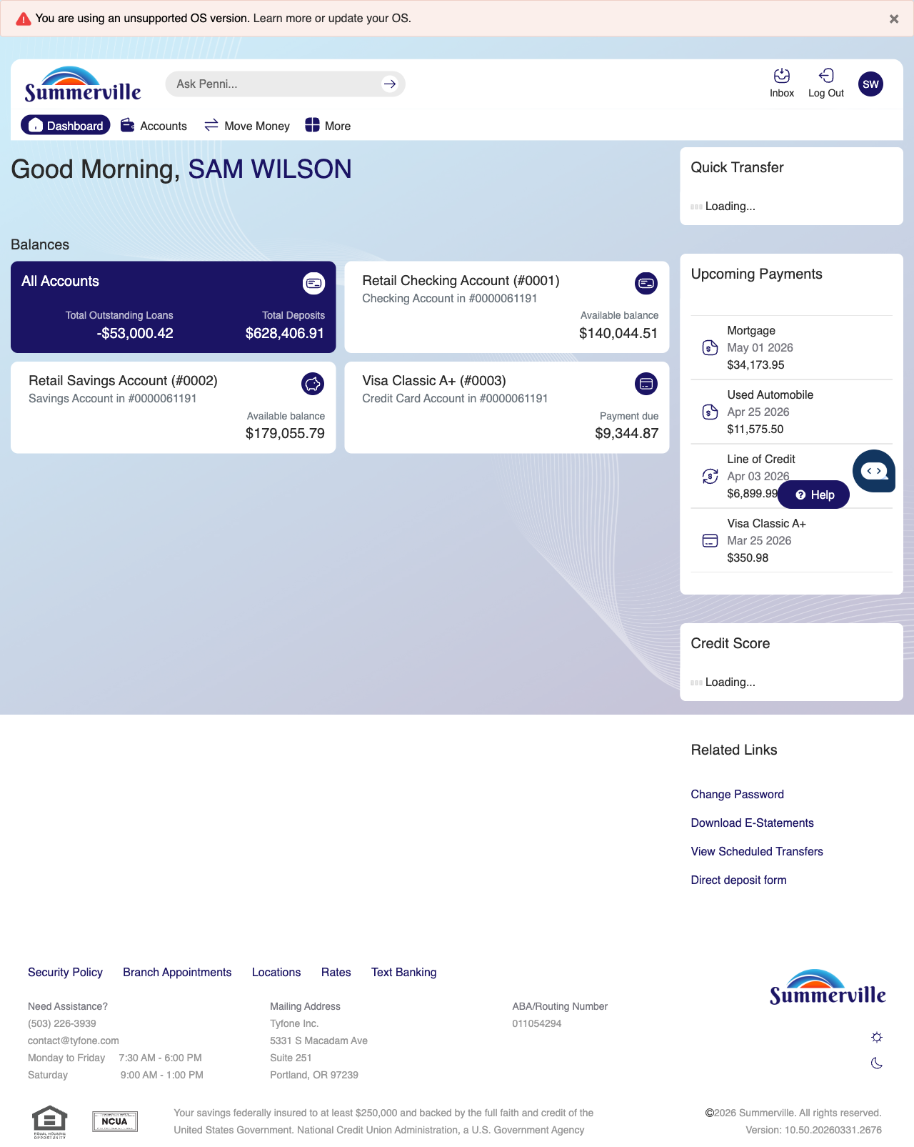
Step 1: Start from Dashboard

Step 2 — Open the More Menu
The member clicks ‘More’ in the top navigation bar. The More options panel expands to show additional features: Check Deposit, User ID and Password, eDocuments, Account Alerts, General Alerts, Password, Forms, One-Time Passcode, Skip A Pay, Do-Not-Disturb, Manage Devices, My Insights, Alert Settings, Recent Activities, and Card Services.
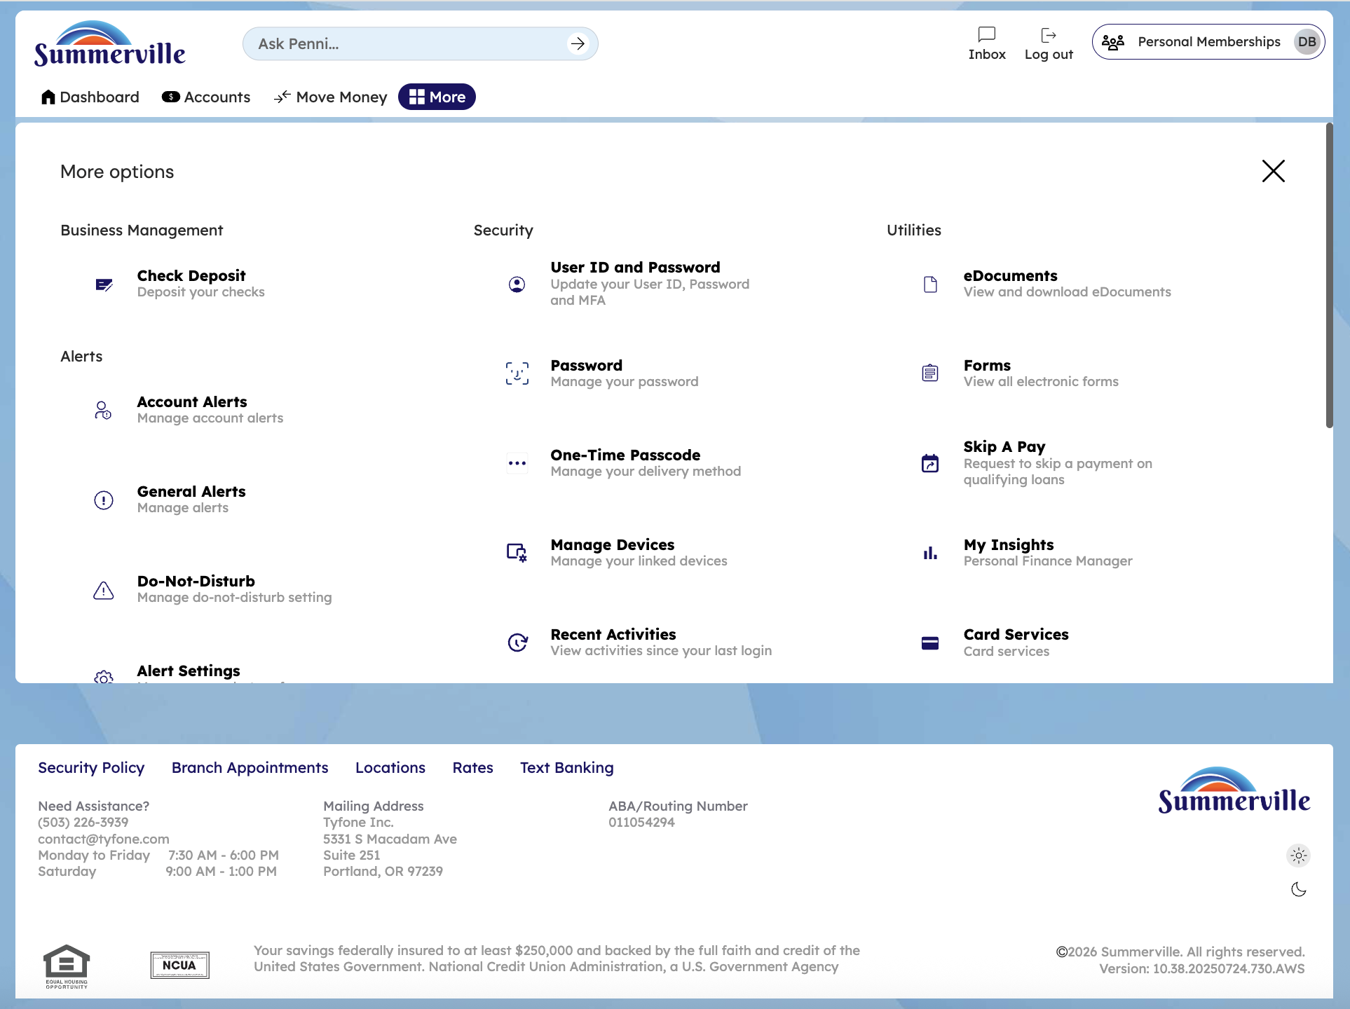
Step 2: More Menu

Step 3 — Navigate from Dashboard to Settings
The User ID and Password Settings page is displayed with a password change form containing 'Enter a new password' and 'Confirm new password' fields, along with a list of Password Requirements.
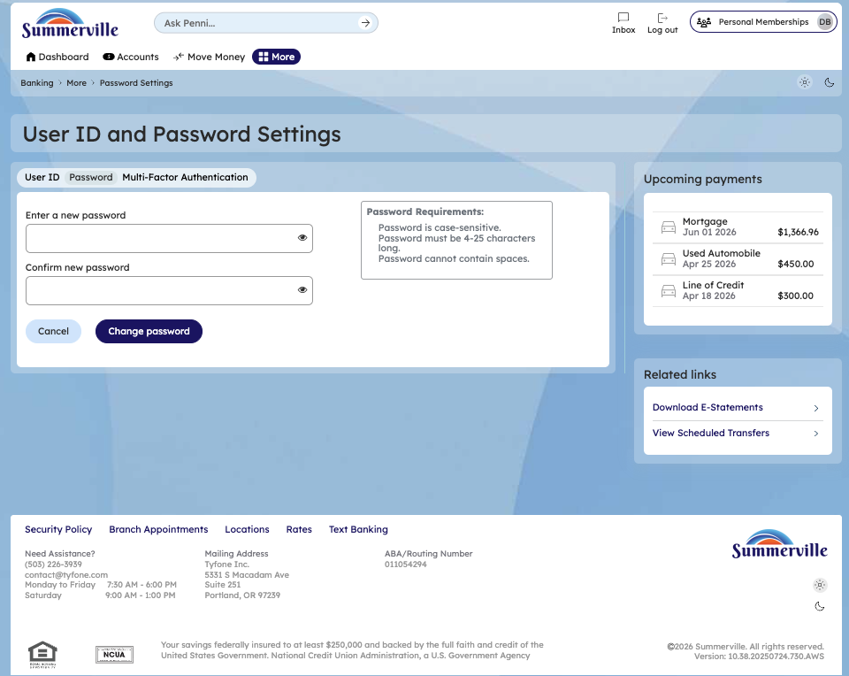
Step 3: Navigate from Dashboard to Settings

Step 4 — View MFA Settings
The User ID and Password Settings page shows tabs for User ID, Password, and Multi-Factor Authentication options available for the member to configure.
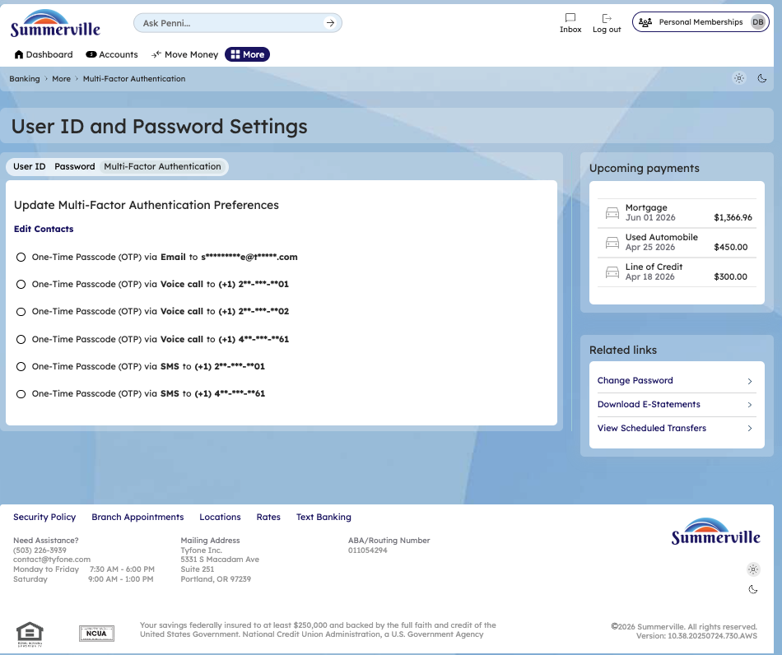
Step 4: View MFA Settings

Step 5 — View Accounts & Memberships Settings
The Accounts and Memberships settings page is displayed with checkboxes for managing membership and account preferences.
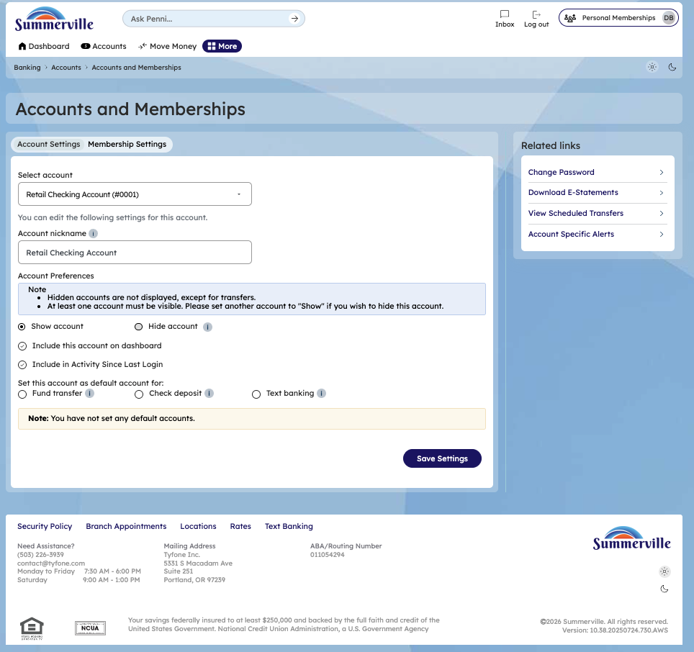
Step 5: View Accounts & Memberships Settings

Step 6 — Update MFA Preferences
The Alert Settings page shows alert configuration options with toggle switches for enabling Push Notifications and SMS Alerts delivery channels.
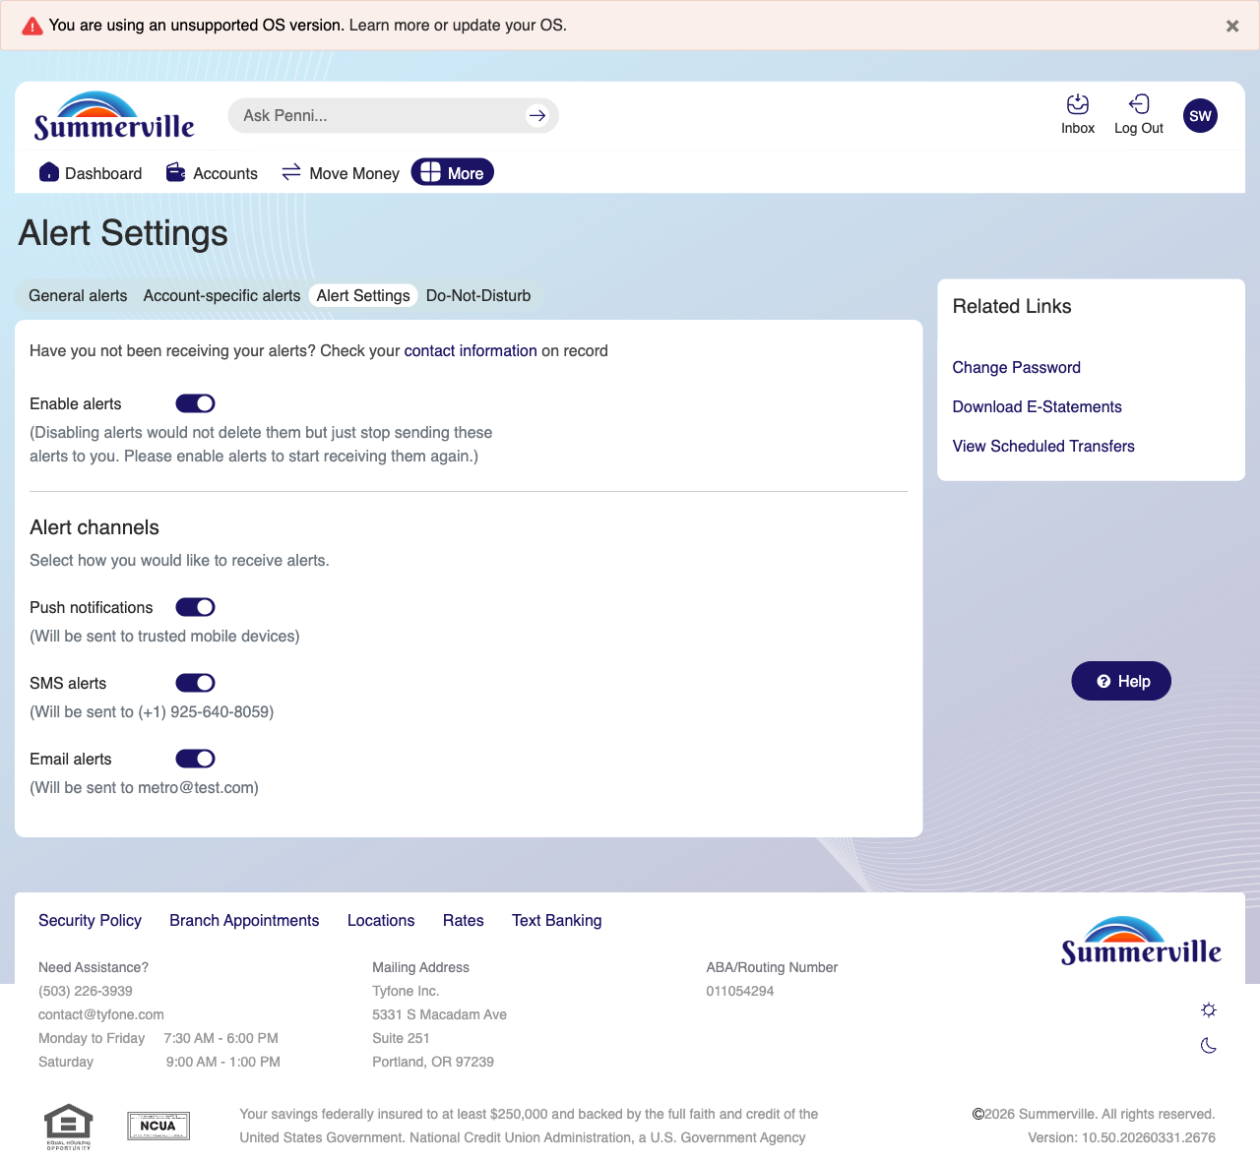
Step 6: Update MFA Preferences

Step 7 — Additional Accounts & Memberships View
The Accounts and Memberships settings page is shown with a loading state and options for managing memberships and account display preferences.
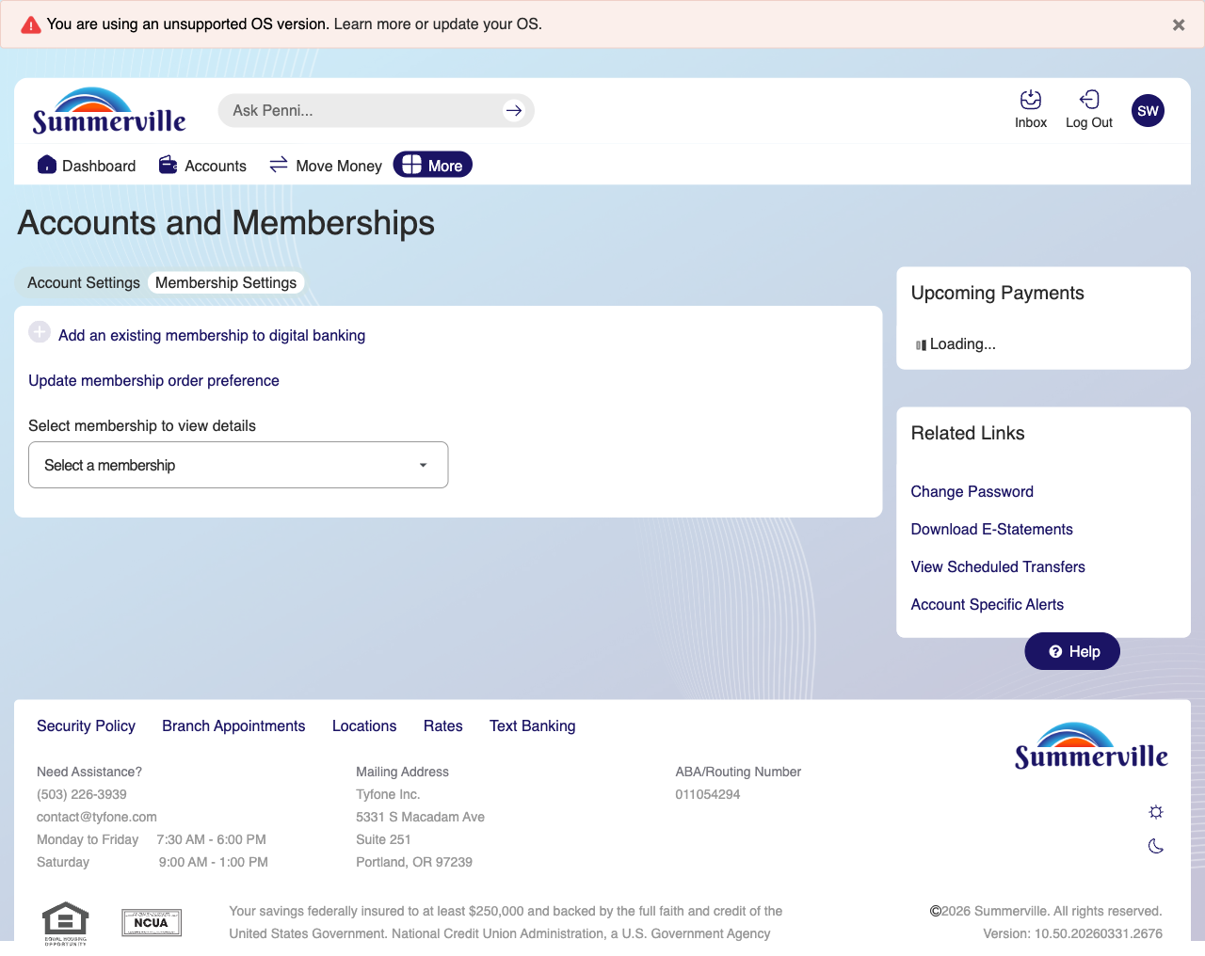
Step 7: Additional Accounts & Memberships View

